**AIM: WORKING WITH SWITCHES, LEDS, AND MORE: SUCH AS INTERFACING LED’S, SWITCHES/PUSH BUTTONS AND SPEAKERS/BUZZER, LCD/ SEVEN SEGMENT DISPLAY WITH ARDUINO.**

**THEORY:**

**LCD:**

These LCDs are ideal for displaying text/characters only, hence the name ‘Character LCD’. The display has an LED backlight and can display 32 ASCII characters in two rows with 16 characters on each row. Each rectangle contains grid of 5×8 pixels If you look closely, you can actually see the little rectangles for each character on the display and the pixels that make up a character. Each of these rectangles is a grid of 5×8 pixels. Although they display only text, they do come in many sizes and colors: for example, 16×1, 16×4, 20×4, with white text on blue background, with black text on green and many more.

**Buzzer:**

A "piezo buzzer" is basically a tiny speaker that you can connect directly to an Arduino. "Piezoelectricity" is an effect where certain crystals will change shape when you apply electricity to them. By applying an electric signal at the right frequency, the crystal can make sound. If your buzzer has a sticker on top of it, pull the sticker off. From the Arduino, you can make sounds with a buzzer by using tone. You have to tell it which pin the buzzer is on, what frequency (in Hertz, Hz) you want, and how long (in milliseconds) you want it to keep making the tone.

**Push Button:**

The buttons are similar to switches that create and break electrical connections in the circuits. The button plays a transition between ON and OFF state. A single press turns the state ON, while another press turns the state OFF. It means that the button connects the two points in a circuit when we press them.

**SOURCE CODE:**

#include <LiquidCrystal.h>

int buttonPin = 2;

int buzPin = 8;

int buttonState = 0;

LiquidCrystal lcd(12, 11, 6, 5, 4, 3);

void setup()

{

pinMode(buzPin , OUTPUT);

pinMode (buttonPin , INPUT);

lcd.begin(16, 2);

lcd.print("Narender Keswani");

}

void loop()

{

lcd.setCursor(0, 1);

buttonState = digitalRead (buttonPin);

if (buttonState==HIGH){

digitalWrite(buzPin , HIGH);

delay(100);

digitalWrite(buzPin , LOW);

delay(100);

}

else {

digitalWrite (buzPin , LOW );

}

}

**OUTPUT:**

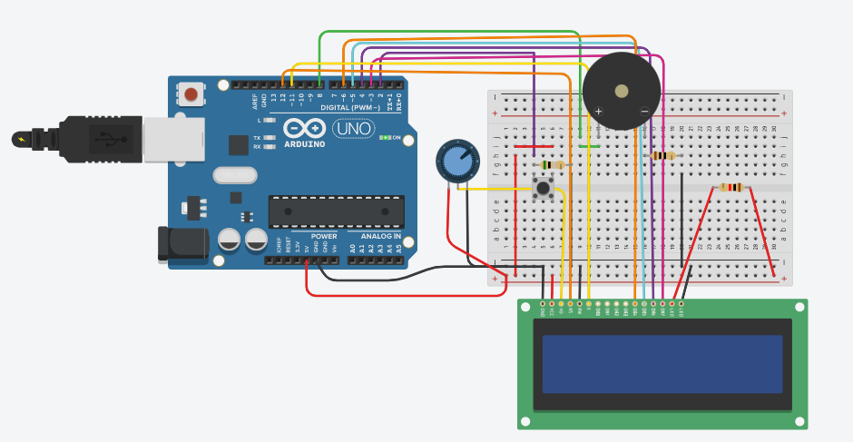

After pressing push button:

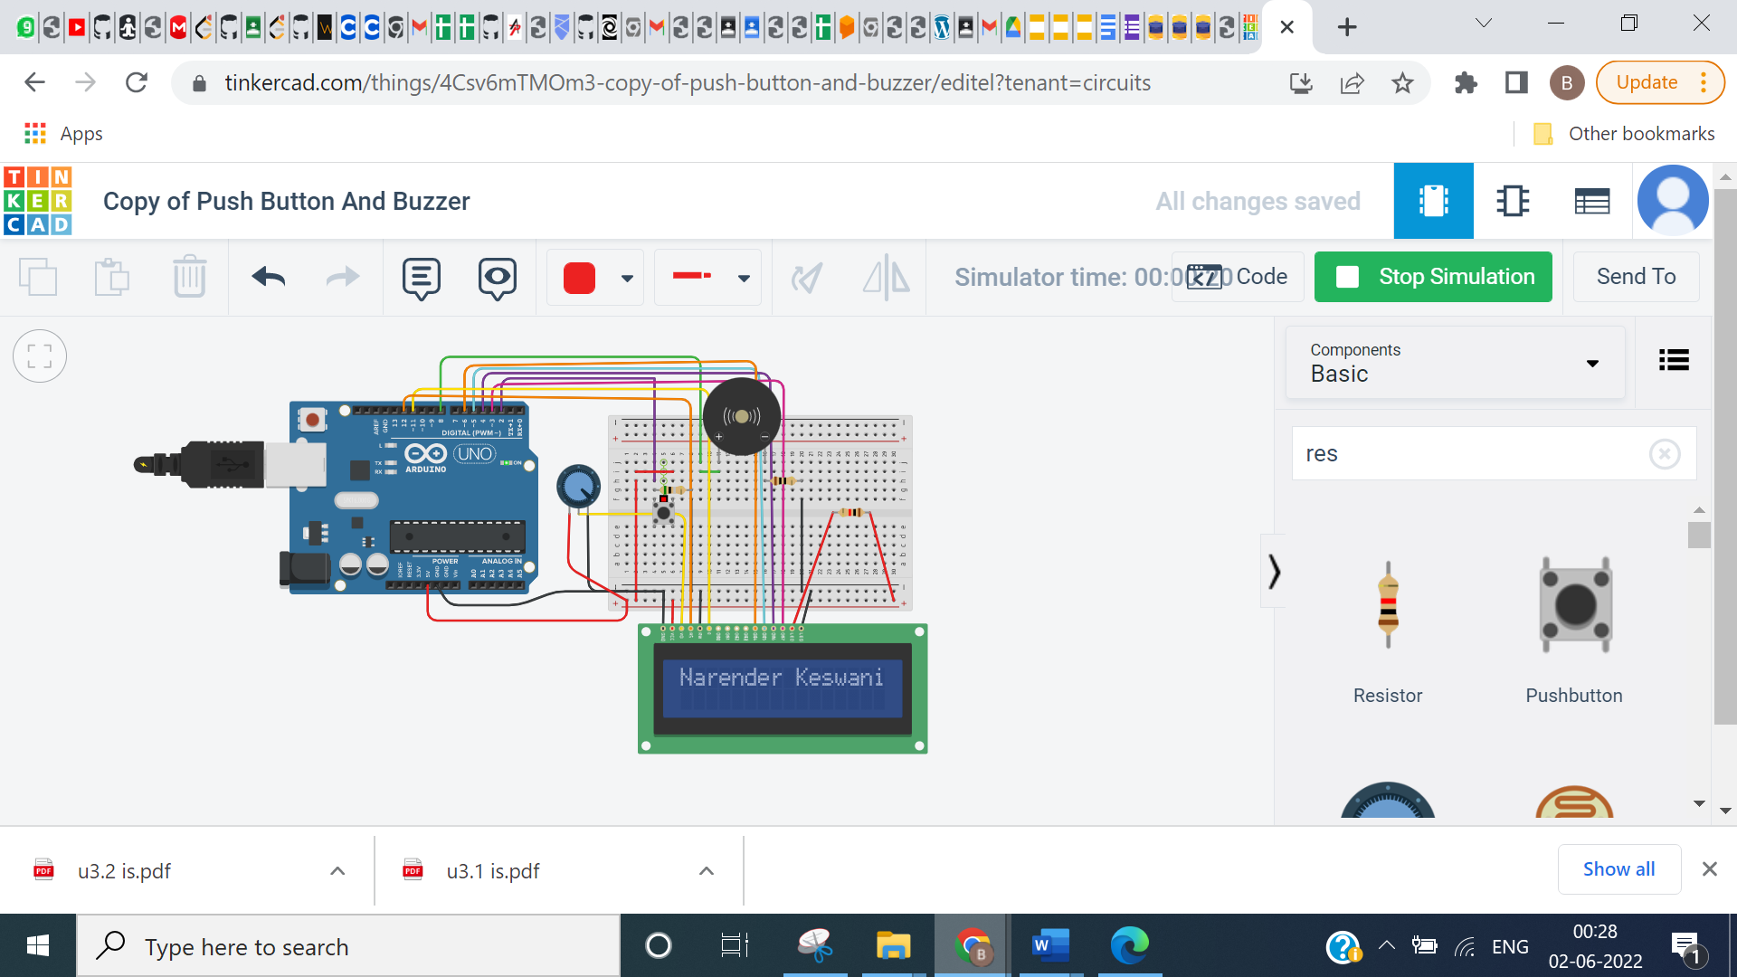

**CONCLUSION:**

From this practical, I have learned how to display text in lcd, connect buzzer with push button.